# Four simple steps to set up a NodeJS web server

The FSC Tomorrow’s Biodiversity visualisation and multi-access key tool is an open source ‘web application’ that runs in a web browser. But it’s not always convenient or desirable to run it on a website, especially while you are developing a knowledge-base. The good news is that you don’t have to. Instead, you can get your own computer to run as a little mini-webserver and run it locally. These instructions tell you how.

## Installation and configuration steps

1. Install **Node.js**: <https://nodejs.org/en/>
2. In your ***tombiovis*** folder, execute ***server-setup.bat*** (e.g. by double-clicking it from Windows explorer). This may take up to a minute or so to run.

## Running the local web server

1. In your ***tombiovis*** folder, execute ***server-run.bat*** (e.g. by double-clicking it from Windows explorer).

## Running the tombiovis web app

1. Start tombiovis by entering the following URL into your web browser: <http://localhost:8080/tombiovis.html>

## Explanation of the above steps

Step 1 installs Node.js® on your computer. This is a ‘one-off’ task. Node.js a JavaScript runtime built on Chrome's V8 JavaScript engine. It is a high-quality open-source development which we will use to run a simple and lightweight local web server, allowing you to run the tombiovis program on your own computer rather than installing it on a website. This is great for development work, e.g. when you are developing a new knowledge base. But it’s also a great way to use the multi-access keys and visualisations on a local computer when you do not want to deploy them to a website.

Step 2 sets up the Node.js dependencies required for the local web server. When it ends, you will notice a new folder in the *tombiovis* folder called *node_modules*. This is another ‘one-off’ task and you shouldn’t need to run it again unless this folder is removed.

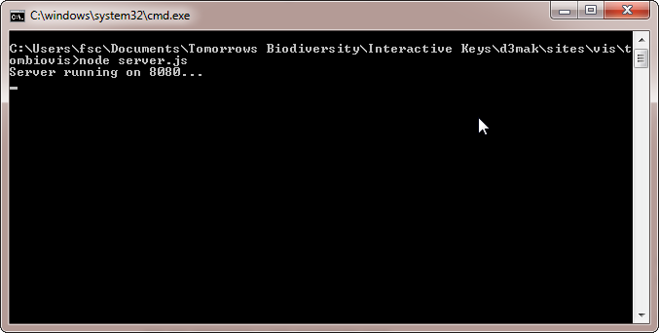Step 3 starts the web server. You may notice a *command shell* (like the one pictured) running on your computer when you have executed this. You can stop the local web server at any time by typing *[Ctrl]C* in this window and responding yes to the question presented. Alternatively, just close the window. If you look, in the Windows Task Manager you will also see a process called *node.exe*. You can also stop the local web server by killing this process.

Repeat step 3 at any time to start/restart the local web server.